ASSIGNMENT - 1

X- CODE

SUBMITTED BY

SAIKIRAN UPPUTURI
(A00083651)

SUBMITTED TO

RAJESH SIR

Welcome to Xcode

Xcode is Apple’s integrated development environment (IDE). You use Xcode to build apps for Apple products, including iPad, iPhone, Apple Watch, Apple TV, and Mac. Xcode provides tools to manage your entire development workflow—from creating your app to testing, optimizing, and submitting it to the App Store.

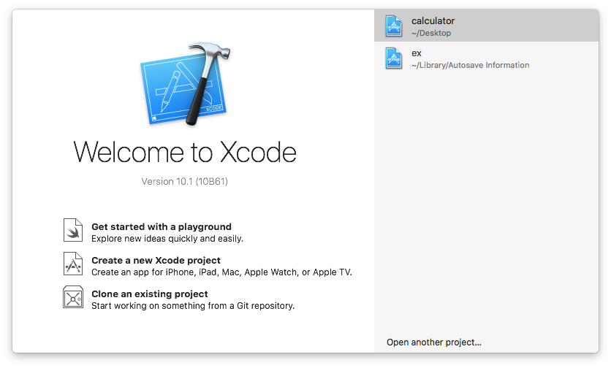
A Project keeps the necessary files and resources for developing your app organized. To create a project, start with one of the templates, then modify it however you like. Templates are available for each platform (iOS, watchOS, tvOS, and macOS) and for common types of apps, frameworks, and libraries. Each template comes preconfigured with default settings and is ready to build and run.

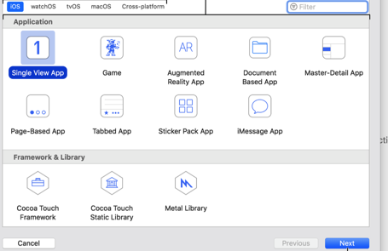

After you create a project, the main window appears. This window is your primary interface for viewing, editing, and managing all the parts of your project. It's flexible and configurable, adapting to the needs of the task at
hand and allowing you to configure it to fit your work style.

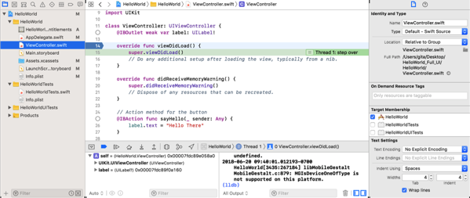

Use the toolbar to build and run your app, view the progress of running tasks, and configure your work environment. You’ll choose a run destination—for example, a simulator or device—from the Scheme menu. (If the toolbar is hidden, choose View > Show Toolbar to show it.) Use the segmented control located on the right of the toolbar to show and hide the different areas of the main window.

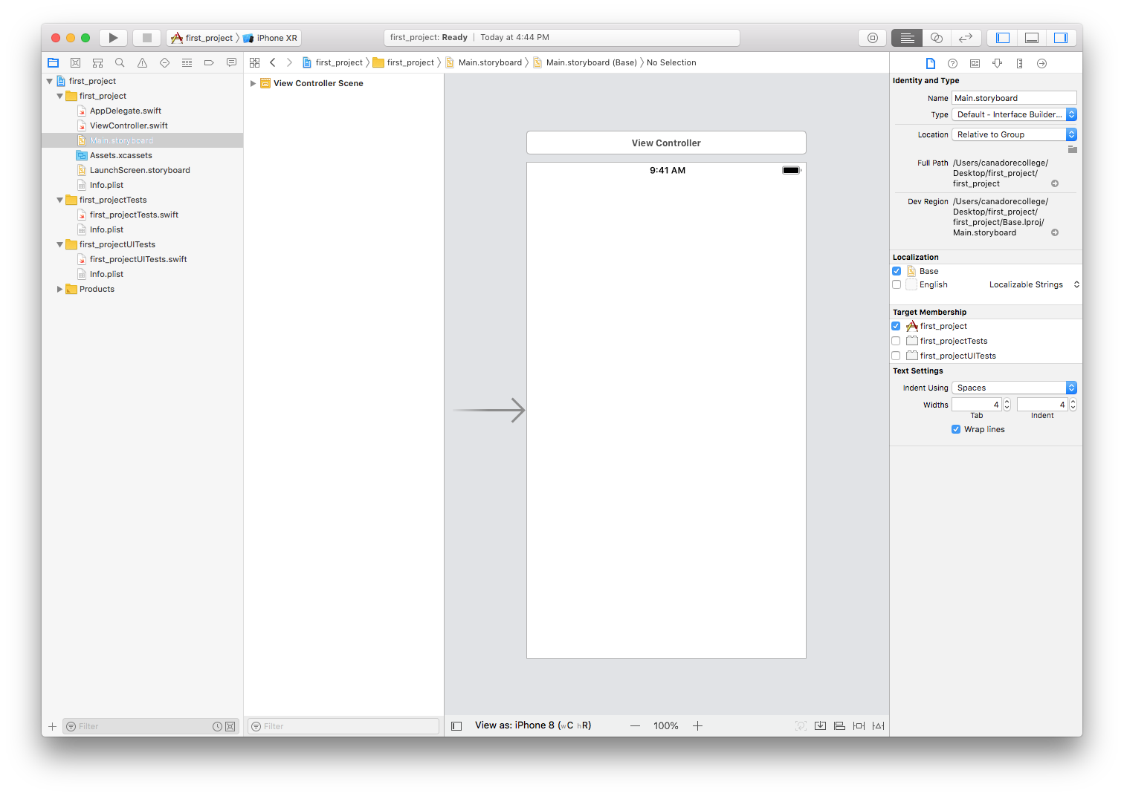
Use the navigator area () for quick access to different parts of your project. Click a button in the navigator bar to show the corresponding parts in the content area below the navigator bar. For example, to view files in a project, click the Project navigator () and the files appear in the content area.

This is the view controller which you can first see the thing when you click the main story board
To use ready-made resources, select a library in the toolbar to open it. For example, select a user interface file in the project navigator, then select the Object library () to access user interface views and controls. Then drag the object you want from the library to the editor area in the main window.
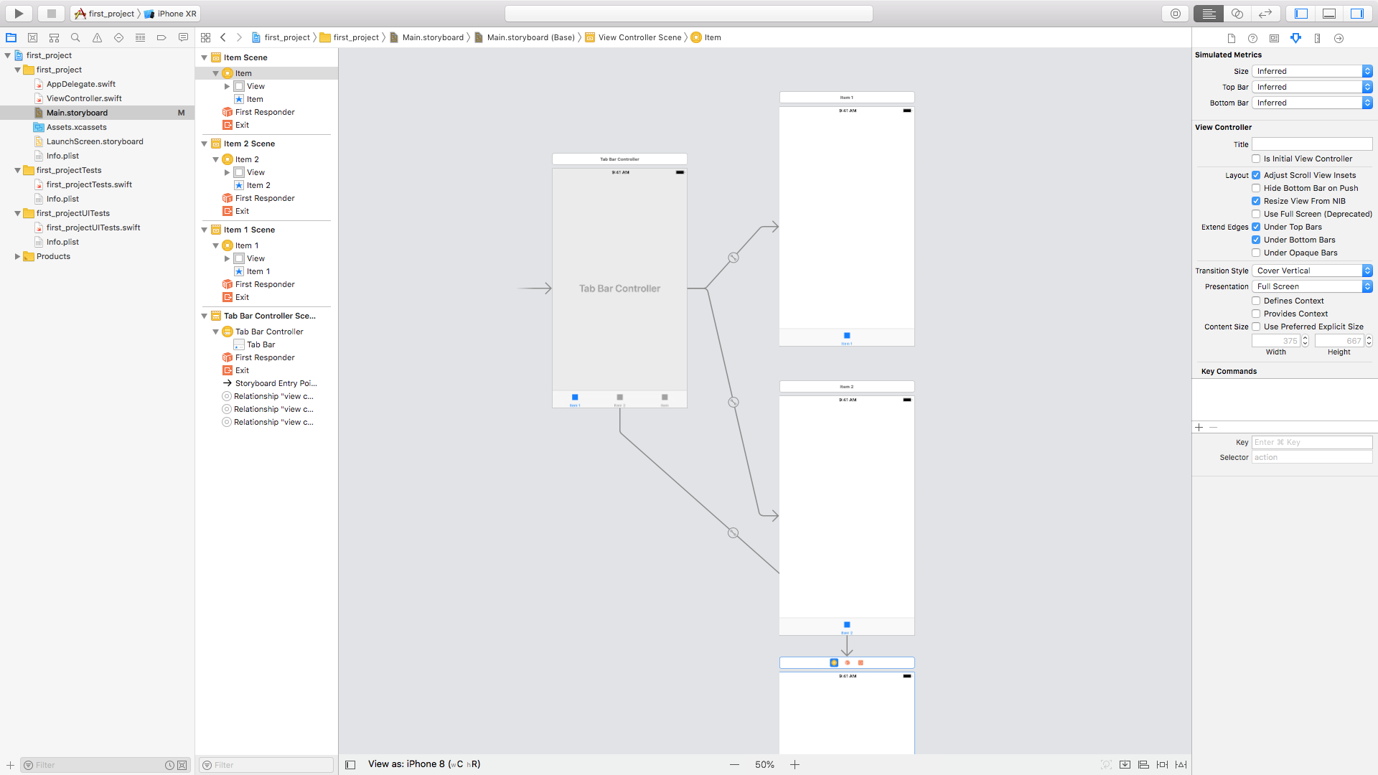

After the above resource done with library you can change the tabs as by aligning them and drag into down by clicking the mouse and select the Tab bar controller which is shown in below

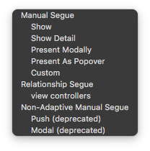

After clicking the view controllers in the above image it connects to the main tab controller and which you allows to the initial view controller

Standard editor

The standard editor have few more options to the tabs that you have at the down
The attribute inspector which allows you to contribute the editor with some
Content mode
Semantic
Tag
Interaction
multiple touch

Some background
Tints

Drawing options

Stretching options
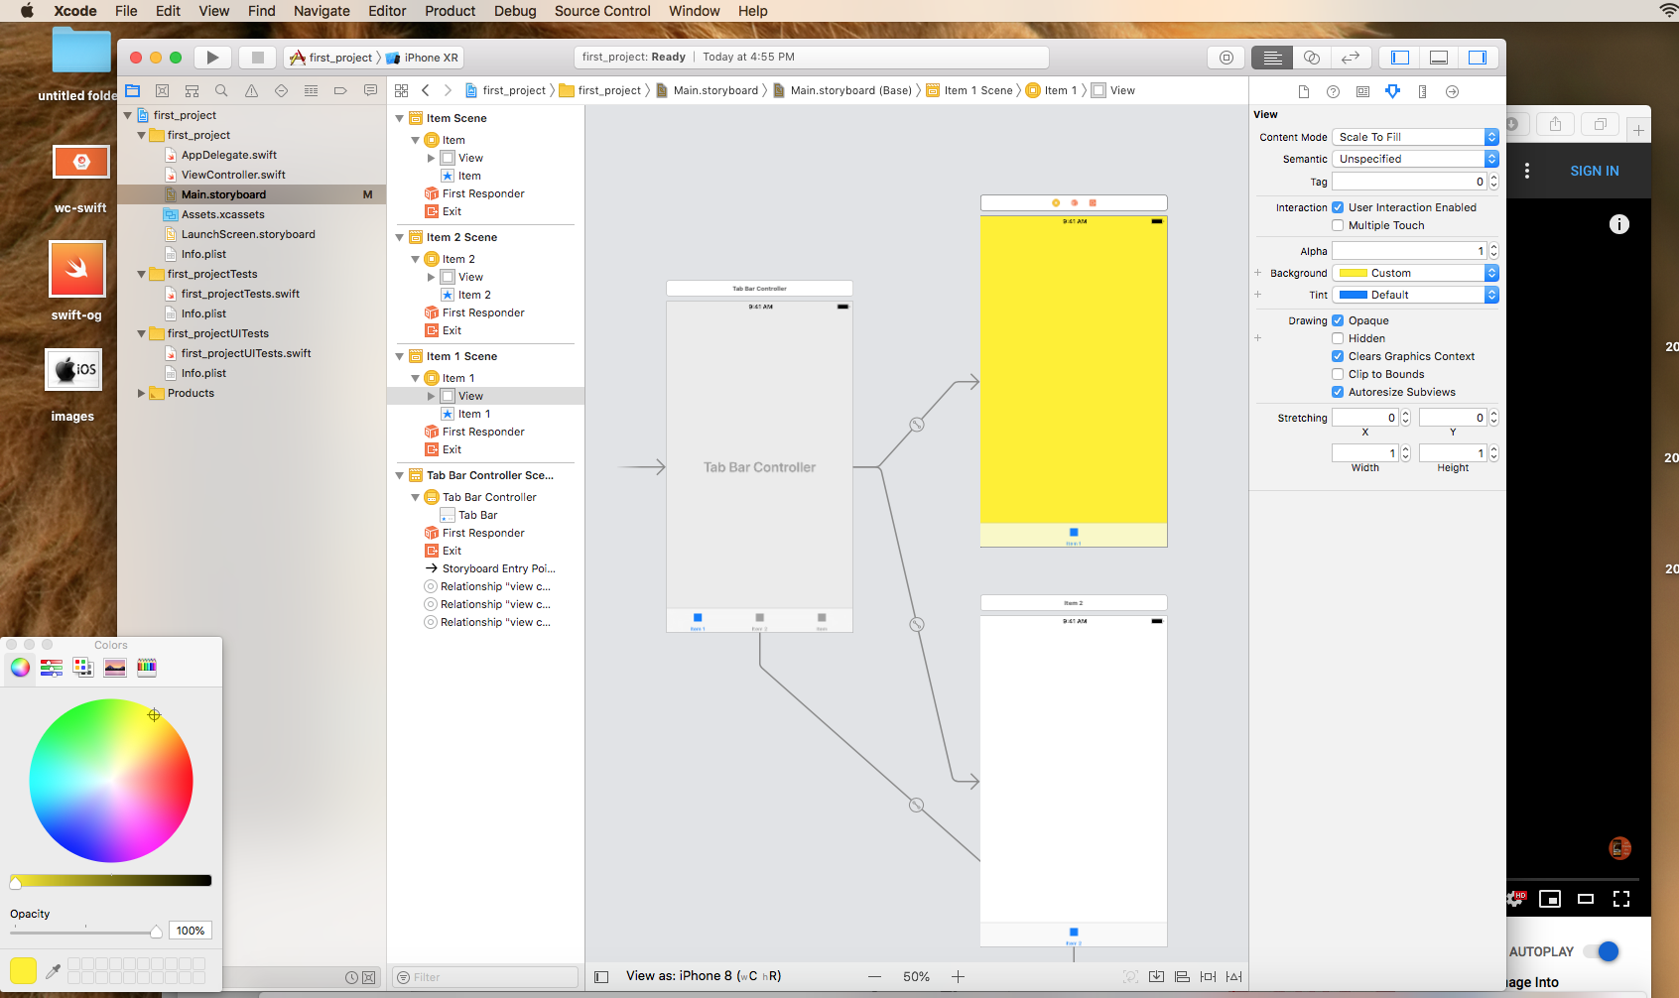

The tabs with the name of three item scenes with three views as an example where you can first change some tag name with standard editor
Where the attribute editor allows you to change the following types

Colour
Text
dynamic type
Alignment
Lines
Behaviour
Baseline
Auto shrink
Some background
Tints and custom options

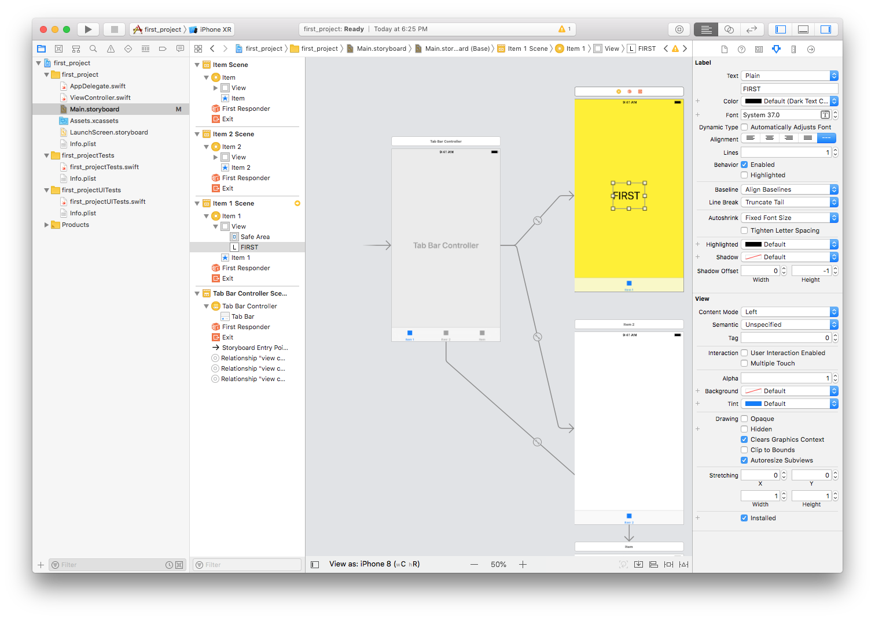

The alignment constraints at the right corner allows the text alignment
Either it is horizontal , vertical or centre
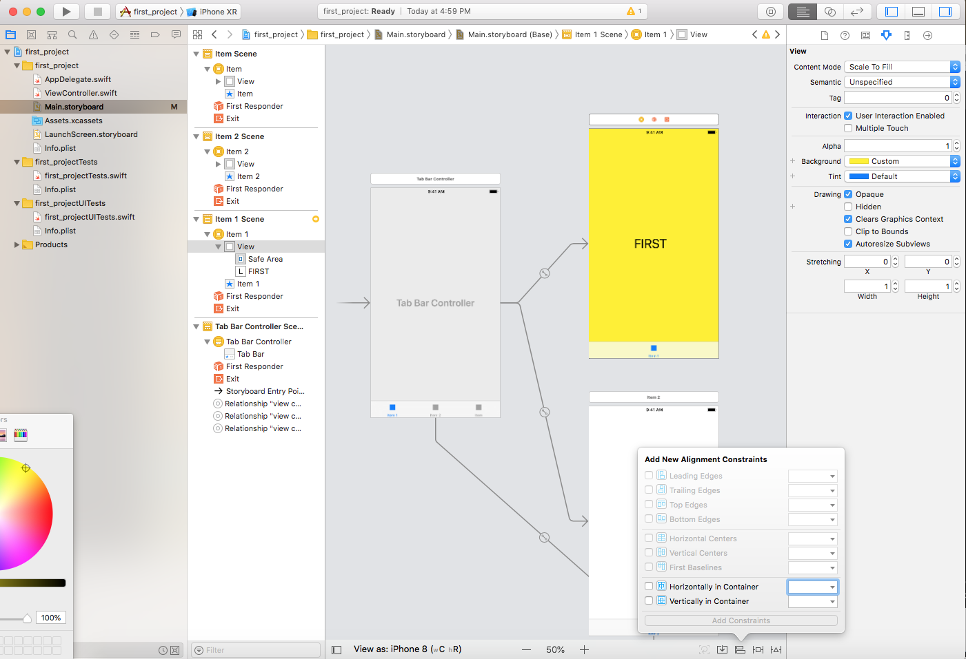

After you create your project from a template, build and run your app to see what the app looks like on a device. For macOS apps, just click the Run button in the toolbar and the app launches on your Mac. For iOS, tvOS, and watchOS apps, you can run your app in the Simulator—a developer tool included with Xcode that simulates devices—or run your app on a real device connected to your Mac. You can also run your app on a device over WiFi after you pair it with Xcode.
Projects can have multiple targets—multiple apps and multiple configurations of the same app. A target specifies a product to build, such as an iOS, macOS, tvOS, or watchOS app. Most projects you create from a template have one target for the main app and other targets for test apps. For watchOS apps, there’s a target for the iOS app, the WatchKit extension, and the WatchKit app. To view the targets, click the Project/Targets button in the project editor

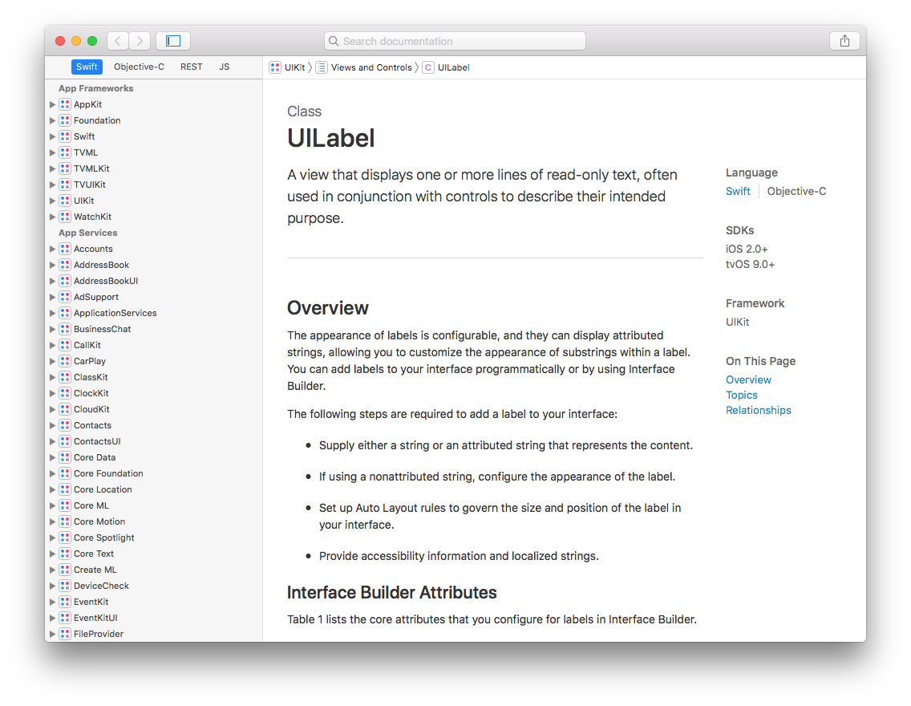
SOME OF THE MORE IMPORTANT SCREEN SHOTS WHERE WE CAN USE OUR PROJECT PORTAL

QUICK HELP

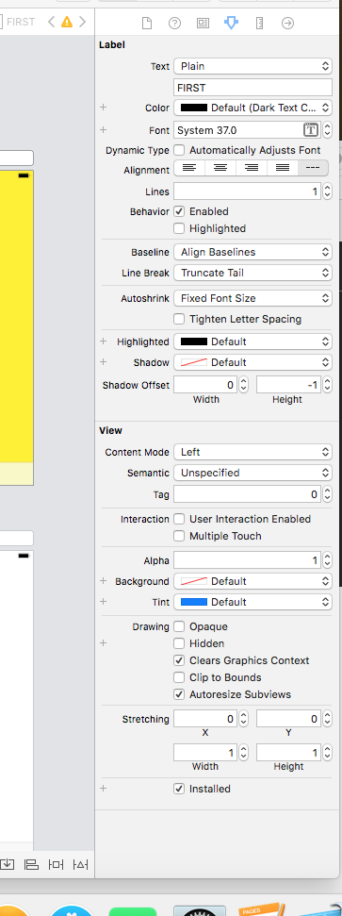
TOOL BAR

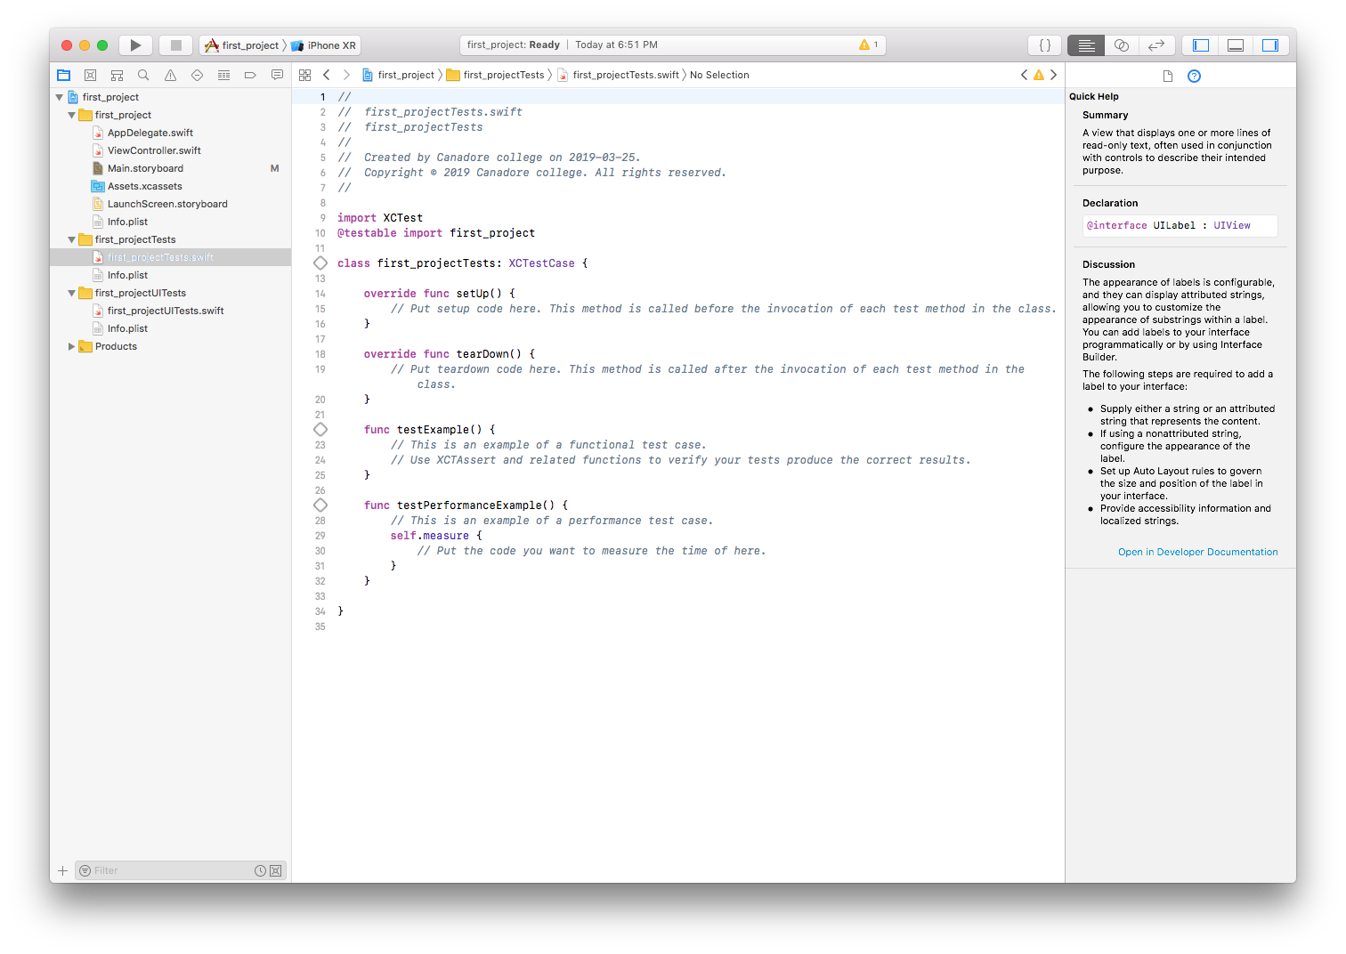

DEVELOPER SPACE

Xcode 10

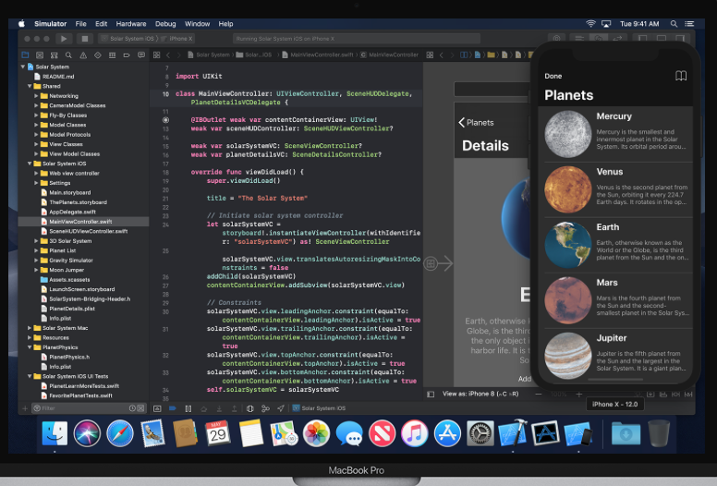
Xcode 10 includes everything you need to create amazing apps for all Apple platforms. Now Xcode and Instruments look great in the new Dark Mode on macOS Mojave. The source code editor lets you transform or refactor code more easily, see source control changes alongside the related line, and quickly get details on upstream code differences. You can build your own instrument with custom visualization and data analysis. Swift compiles software more quickly, helps you deliver faster apps, and generates even smaller binaries. Test suites complete many times faster, working with a team is simpler and more secure, and much more.

Xcode 10 includes Swift 4.2, which compiles your software more quickly, helps you deliver faster apps, and generates even smaller binaries. Compared to Swift 4.0, the latest Swift compiler can build large apps more than twice as fast.* Combined with the new Xcode new build system, your everyday edit, build, and test workflow is much faster.

Tools you’ll love to use.
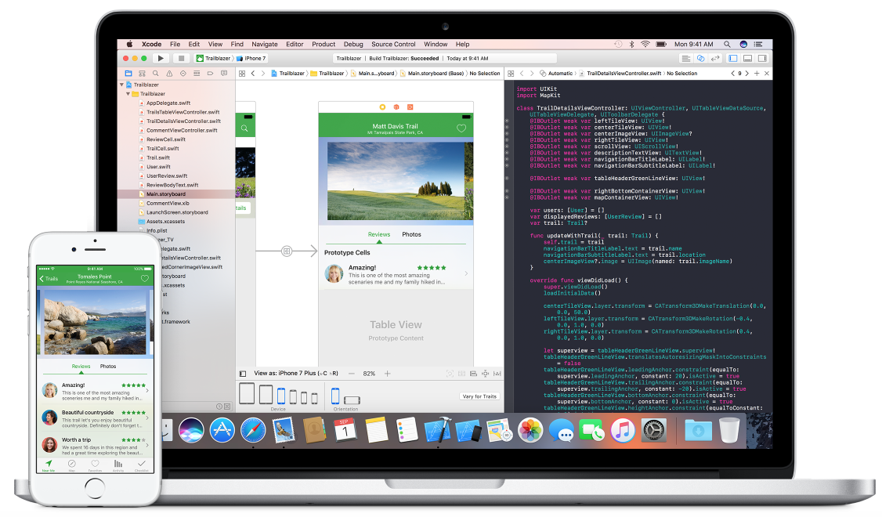
The Xcode IDE is at the centre of the Apple development experience. Tightly integrated with the Cocoa and Cocoa Touch frameworks, Xcode is an incredibly productive environment for building apps for Mac, iPhone, iPad, Apple Watch, and Apple TV.

Assistant Editor
The Assistant button splits the Xcode editor in two, with your primary work document on the left and an intelligent Assistant editor pane to the right. The Assistant editor automatically displays files that Xcode determines are most helpful to you based on the work you are performing in the primary editor.

Interface Builder Built-In
The Interface Builder editor within Xcode makes it simple to design a full user interface without writing any code. Simply drag and drop windows, buttons, text fields, and other objects onto the design canvas to create a functioning user interface.
Because Cocoa and Cocoa Touch are built using the Model-View-Controller pattern, it is easy to independently design your interfaces, separate from their implementations. User interfaces are actually archived Cocoa or Cocoa Touch objects (saved as .nib files), and macOS and iOS will dynamically create the connection between UI and code when the app is run.

